Michael Chizy, Chairman  John L. Hebert, Vice Chairman  Richard Hersom, Clerk  Ryan Fattman  Kevin Geraghty  James A. Smith, Town Administrator | 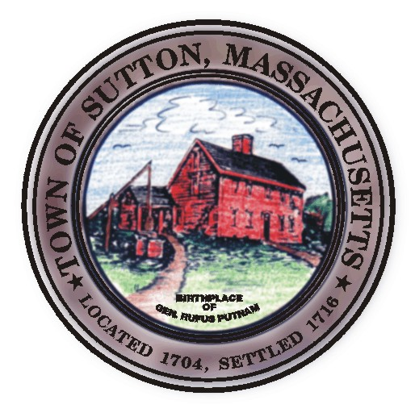 | Sutton Town Hall  4 Uxbridge Road  Sutton, Massachusetts 01590  (508) 865-8727  Fax: (508) 865-8721
Town Of Sutton
Board Of Selectmen

Meeting Agenda

7:00 p.m. – Tuesday, August 5, 2008

Sutton Town Hall, Selectmen’s Meeting Room

- Call to Order, Pledge of Allegiance at 7:00 p.m.

- Public Forum: Limited to 5 minutes per topic. Discussion or comments about town employees or agency members shall be avoided so as not to violate individual’s rights.

- Minutes
  - Board of Selectman minutes from 07/15/08

Proclamation in honor of Eagle Scout David John Surprenant

IV. Sponsored Agenda and Action Items

****** PUBLIC HEARING ******
Class I & II Dealers License :
2. D.R. Stone Inc. dba Car Custodian Ray Stone owner (previously owned by Mr. Jan Hanratty)

3. Authorization of MORE Grant
4. Discussion on Quarterly Billing
5. Board of Selectmen appointee to Designer Selection Panel

V. Town Administrator Update
VI. Announcements
VII. Selectman’s Roundtable: Correspondence and Business Topics

Adjournment

